**CLASS VIII PAPER COMPUTER**

**SECTION A**

**Q1.a Fill in the blanks (2.5)** a. The <li> tag is a .............................. item tag.b. An .............................. list is also called a numbered list. c. An .............................. link provides a link to a point on the current web page. d. The HTML tag which is used to create a link is the .............................. tag. e. The .............................. command helps to add a new clip between two clips.

**Q1 b.Write T for the true statement and F for the false one.(2.5)**

a. An unordered list is used for items in which the ordering of items is not important.

b. An ordered list uses bullets as the list item marker. c. An image cannot be inserted in a table cell. d. Video cannot be inserted in a web page. e. The edit viewer has a white border. **Q1 c. Give three facts about the following: (2.5**) a. Working with Audio b. Lightworks

Q1d. (2.5)

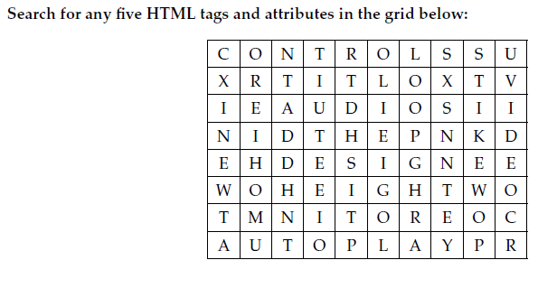

**SECTION B ( SHORT QUESTION ANSWER )(do any 6 and part (a) is compulsory (25marks))**

a.Name the tags used for creating ordered and unordered lists? b.What is purpose of the **<dd>** tags? c.What are the tags required to create a description list? d.What do **GIF**  and **PNG** stands for? e.What is the difference between the **<td>** and **<tr>** tags? f. Name the tags used to create a link .Name one attribute used with this tag? g.Name all video extensions which you can use in **LIGHTWORKS**? h.What is the purpose of the **src**  and **control** attribute of the <audio> tag?

**SECTION B ( SHORT QUESTION ANSWER )(do any 3 (15 marks))**

**a.Differentiate between an ordered and unordered list ? b.Which tag is used for inserting the image to be displayed in HTML document? Mention any two attributes of this tag? c. Describe the different kinds of links that can be created on a web page d)Explain the mark and park procedure of marking a clip. e)How will you export the edited file to your desktop?**